

BOXGROVE CofE PRIMARY SCHOOL
Learning, Loving and Growing, together with God.
This is a school where everyone is valued, nurtured and enabled to flourish. Through our Christian Faith, we acknowledge our responsibility to all, to enrich lives and show love and respect within our school family. We believe in curiosity and lifelong learning, aiming to equip our children to live life today and for tomorrow as confident and resilient individuals. Central to our vision is the following verse from I John 4.16
“God is love and those who live in love, live in God and God lives in them.”

POLICY: Relationships and Behaviour for Effective Learning

Monitoring and Review of Policy
Last update (reviewed at FGB): November 2024
Next update due: November 2025

Relationships and behaviour for effective learning policy

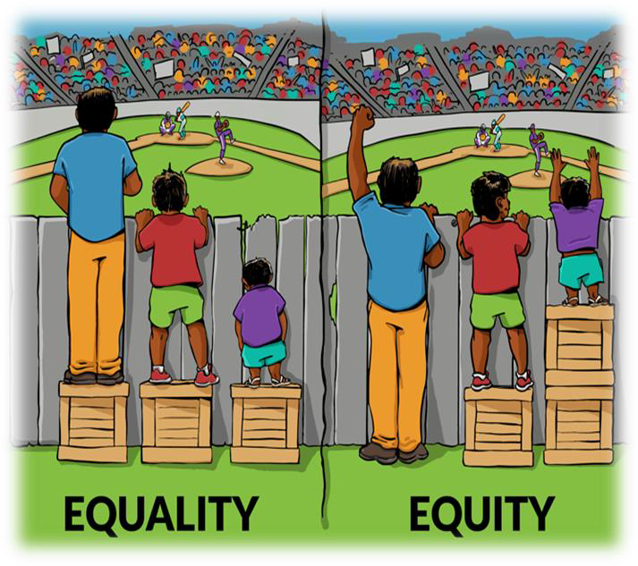
At the heart of our Behaviour Policy lies our school’s Christian vision: “Learning, Loving and Growing, together with God.” In our school, everyone is valued, nurtured, and enabled to flourish within a positive, inclusive community where faith and respect guide us. Inspired by the belief that "God is love, and those who live in love, live in God and God lives in them" (I John 4.16), our behaviour principles are rooted in love, compassion, and respect for each unique individual.
We believe that positive behaviour stems from strong, consistent relationships between staff and pupils. Relationships are the foundation of a positive culture across our school. As adults, we are called to show unconditional positive regard, noticing and celebrating the behaviours we wish to see, and acting as champions for every child.
“Every child deserves a champion—an adult who will never give up on them, who understands the power of connection, and insists that they become the best that they can possibly be.” Rita Pierson
In our school, we see behaviour as a form of communication. Our responsibility as educators is to understand what children are telling us through their behaviour and to provide guidance and support. We know that only when children feel safe and respected can they achieve their best. To foster this, we establish consistent, clear, and firm boundaries, promoting positive learning behaviours.
“The idea that behaviour management is simply about learning a set of techniques that emerge from a teacher’s toolkit is a dangerous one. With the right culture, the strategies that are used become less important. The culture is set by the way the adults behave.” Paul Dix
Our commitment to nurturing respectful, outward-looking individuals is also reflected in our curriculum’s Core Values:
- Wisdom: Developing our head and body—What we learn.
- Compassion: Developing our hearts and character—Who we are.
- Resilience: Developing our actions and attitudes—How we live and learn.
- Respect: Developing our moral compass—Where we fit in the world.
Our approach to behaviour is deeply integrated into our Christian vision and the Church of England’s Vision for Education. Together, we aim to educate not only for knowledge and skills but for hope, community, and dignity, building a culture that enables every child to flourish in faith, learning, and life.
Brilliant Boxgrove Behaviour
We teach and reinforce our 3Bs of Boxgrove Brilliant Behaviour through daily teaching and the relationships we build.

Be Ready: Ready to learn and ready to help others learn
Be Safe: We keep ourselves, and others safe
Be Kind: Kind to others and respectful of ourselves

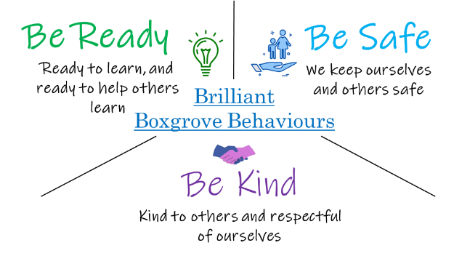

Our Guiding Principles
- We, as adults, model calm, controlled and caring behaviours.
- Our attention as adults is focused first on those children who are behaving in an expected way.
- We look to highlight the children going ‘over and above’ and give them the formal recognition.
- We define, as a school, what we will consistently do: recognition, expectations, and routines.
- We use scripted interventions and consistent language.
- All behaviour is communication (an un-met need) and not a deliberate attention seeking act.
- Behaviour can be taught and improved through support and guidance.
- A calm, consistent and predictable environment promotes positive behaviours.
- High standards of behaviour are essential for effective learning.
- In line with our Christian ethos, a new day is always a new start!

Expectation of adults.
Consistent adult behaviour will lead to pupils consistently meeting our expectations.

Adults will:
- Meet and greet first thing in the morning using the child’s name and giving eye contact.
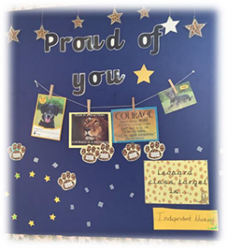
- Refer to ‘Be Kind, Be Safe, Be Ready’ regularly and consistently and notice the children demonstrating our Brilliant Boxgrove Behaviours.
- Plan lessons that engage, challenge and meet the needs of all learners.
- Use a visible recognition mechanism throughout every lesson (e.g. Recognition boards) to promote desired behaviours and reach specific goals.
- Be calm and always give ‘take up time’ when going through the steps to prevent behaviours escalating.
- Be unconditionally positive in our interactions and use affirming language.
- Talk to learners who are not demonstrating Brilliant Boxgrove Behaviours and make every conversation a learning opportunity using a praise in public, reprimand in private approach. (PiP&RiP)
- Follow up behaviours promptly and support children to be reflective in order to support the understanding and learning of our Brilliant Boxgrove Behaviours.

The Headteacher will:
- Take time to welcome adults and children at the start of each day.
- Be a visible presence around the site and especially at transition times.
- Celebrate staff and children whose effort goes above and beyond expectations.
- Regularly share and celebrate good practice.
- Use behaviour data (recorded on bromcom) to assess and evaluate school wide behaviour policy and practice.
- Regularly review provision for learners who fall beyond the range of written policies.

Ways we celebrate and notice:
We recognise and reward learners who go ‘over and above’ our standards as well as demonstrating our Brilliant Boxgrove Behaviours. Our staff at Boxgrove recognise the power of praise in developing a positive atmosphere in the classroom. For some children a quiet word of personal praise can be as effective as a larger, more public reward. Praise is the key to developing positive relationships and adults will need to adjust this according to the individual needs of each child.


Positive rewards include:
Celebration Assembly – A child from each year group is rewarded weekly with a certificate for showing one of the school values or Brilliant Boxgrove Behaviour.

Hot Chocolate Raffle – Children who have gone over and above in demonstrating acts of kindness and/or compassion during playtimes will be entered into a raffle to join a hot chocolate circle with Mrs Dommett.

Marble Jars – The class will win collective prizes (that they decide at the start of the term) when they reach milestones in marble jars. Children get given a marble when they have demonstrated Brilliant Boxgrove Behaviours or shown school values.

Positive Verbal Feedback to Parents – Staff will communicate with parents/carers at the end of the day or via a phone call home when their child has gone over and above in the learning behaviours they have demonstrated.

Stickers – Children may be given stickers for demonstrating our Brilliant Boxgrove Behaviours

Walk of Fame (VIP) – When children have done exceptional learning, they will wear a special VIP lanyard and take their learning on a VIP tour to share with other classes.

‘Every Time’ children – Children who consistently demonstrate our Brilliant Boxgrove Behaviours or show school values will receive a postcard from Mrs Dommett at the end of each term.

First Attention to Best Conduct
You get more of what you notice the most…
It’s easier to notice disruptive behaviour so it requires a shift in mindset and the deliberate intention to create a positive classroom culture.

We will model and teach positive and strong relationships in a variety of different ways including PSHE, RE and through our four core values of:
- Wisdom
- Compassion
- Respect
- Reslience

Opportunities for children to live these values and deepen their understanding include:
    - Carefully planned and sequenced lessons of RE and PSHE
    - Collective Worship including Picture News
    - Additional intervention/small group lessons
    - Trusted adults (where appropriate)
    - Additional support (Nurture/ELSA)

Use of language and restorative conversations to support children

We ensure that the language we use is consistent, affirmative, aspirational, and always communicates high expectations. If something is difficult for a child or they are finding it difficult to regulate or show ‘Brilliant Boxgrove Behaviours’ then we can support them in a number of ways.

Guided conversations: Children can use visuals to communicate what has happened using our
‘Problem Cards’ These focus on four key questions:
- What happened?
- How were you feeling?
- What can we do next time?
- How can we make it right

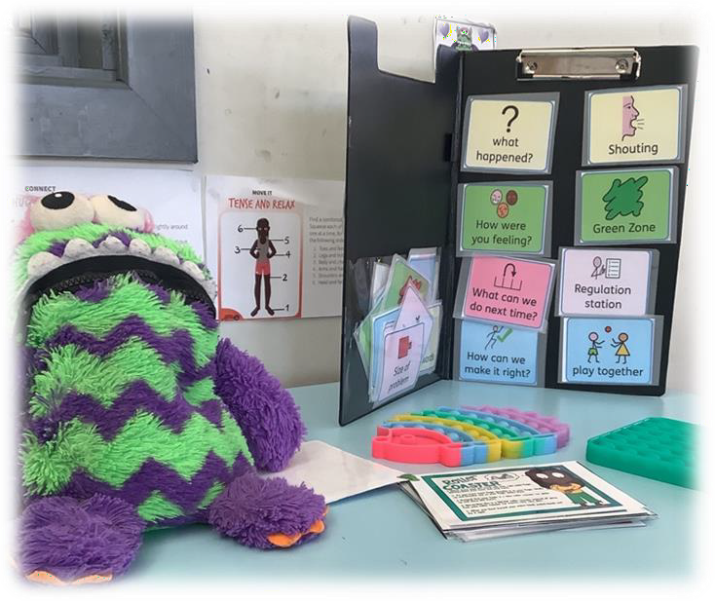
Regulation stations: Children can regulate in class or in the learning den by using a ‘Regulation
Station’. The children are taught to use these and have access to various calming strategies and tools to help them. If they cannot do these independently, then children will be given the opportunity to co-regulate with an adult.

calming strategies: Across the school, children are taught strategies explicitly and are actively encouraged to use these to calm and regulate.

Restorative conversations: These simple and clear conversations help resolve issues whilst maintaining relationships, they help prevent future disruptions, strengthen the child’s connections with others and keep our children connected to our positive school community.

Supportive steps (including Zero behaviours)

What are zero behaviours?
These are behaviours that put a child, their peers or the adults around them in an unsafe position. Some examples include:
- Leaving the classroom without permission
- Leaving the school premises (absconding)
- Physical or emotional harm to another child or adult (this includes acts of racism, homophobia, acts of sexism and other forms of discrimination)

Stages of support

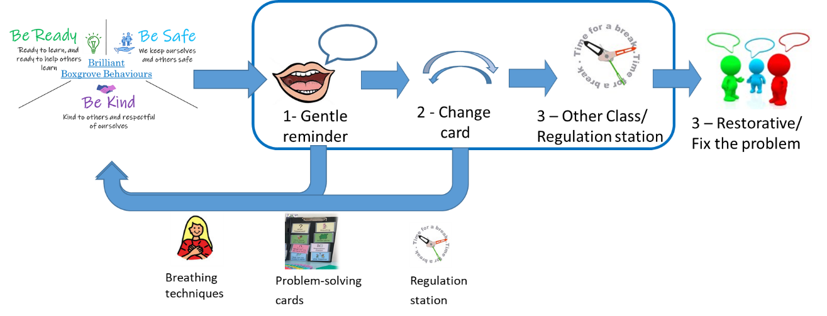

The purposes of these stages of support are to provide an opportunity for children to make changes to their behaviour (with the support of adults around them) so that they can ‘Be Ready to learn’.
For the large majority of children our stages enable them to achieve this. However, there will be a small minority of children who will need alternative consequences to be applied e.g. missing part of playtime or a phone call home to parents. This will be used at the teacher’s discretion.
1) Gentle reminder | Gentle encouragement (opportunity for adults to reflect on context around the child), a ‘nudge’ in the right direction.  A reminder of our ‘Brilliant Boxgrove Behaviours’ – Be Kind, Be Safe, Be Ready delivered privately, wherever possible.  Repeat reminder if necessary. De-escalate and decelerate where possible. Immediate praise will be given if the learner is able to model good behaviour as a result of the reminder.
2) Make a Change | The learner is supported and encouraged to do the right thing. Learners will be reminded of their previous good conduct to prove that they can make sensible choices.  Use the 30 second scripted intervention  - Celebrate and point out the desired behaviour in classroom  ‘I can see by your listening body that you are ready to learn x.  Thank you.’  - Remind children of our Brilliant Boxgrove Behaviours  - Remind children they CAN:  ‘I saw you practising your spellings as soon as you came into class yesterday. You were ready to learn.’  - State what needs to change  ‘You need to have your book out to show me you are ready for learning.’  - Thank the child and give take up time  - Learners can choose to use regulation station, use problem solving cards (independently) and/or calming techniques at this point
3) Partner Class teacher/Regulation Station  * Calm greeting from the partner class teacher *  (Short restorative conversation with the class teacher at a time that is appropriate based on the needs of the child) | Time (at teacher’s discretion) in either partner class or regulation station (with time limit) in learning den.  It is purposeful time given to a child to calm down, pause, look at the situation from a different perspective and compose themselves, ready for a restorative conversation and welcome back into class.  Short restorative conversation with the class teacher  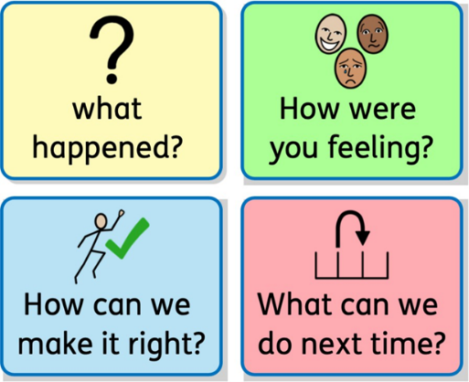  If a child has an incident requiring support at stage 3 then the class teacher must inform parents/carers in person or via phone call This must be recorded on bromcom.
4) Refer to HT Or  Zero behaviour  Internal Seclusion | If behaviours persist following the implementation of the above steps then the HT will be informed using a walkie talkie.  HT will offer support, however if the member of HT is not able to respond due to being with another child then they will respond as soon as they can.  In the event of a ‘zero’ behaviour a child will receive ann internal seclusion for up to half a day and the following will be in place to support this:  - Child and parents to be told and given reason why (linked back to zero behaviour)  - Where possible this will take place in the HT office, if not, the staff present will decide on the appropriate classroom.  - There will be a greeting from the HT or class teacher and space for the child set up (where they will be having internal seclusion)  - They will miss their playtime (a physical break will be offered at another time)  - Appropriate learning will be given to the child which can be completed independently and will be celebrated by their class teacher on return to class.
Fixed Term Suspension | Suspensions are a last resort and only applied when behaviour is placing children and/or staff at risk of physical harm.  Behaviour can escalate to this stage without the opportunity to go through the previous stages.  In the event of a child with an additional need SEND/SEMH is suspended. The school expects the child will have had the support and full implementation of any plans and strategies which meets their needs.  The school has a clear process in place to ensure parents/carers via a phone call in a timely manner regarding a Fixed Term Suspension and ensure that the child is supported to return to school successfully.  Learning packs matched to the child’s needs will always be sent home with a child on a FTS
If a child has an incident requiring support at stage 4 then the class teacher must inform parents/carers in person or phone call. This must be recorded on bromcom.
If a child has three or more incidents in a week (or regular incidents) requiring support at stage 3 or above, this will require a teacher/HT/SENDCo family meeting to revise support in place for individual children/family.
Our guiding principles are to always try and be proactive in our approaches and avoid, at all costs, fixed term exclusions.

